Hello Claude,

Below is a rough draft how I envisage front end exposure interface and load balancing / scaleing. This is drawn the old way, match box style.

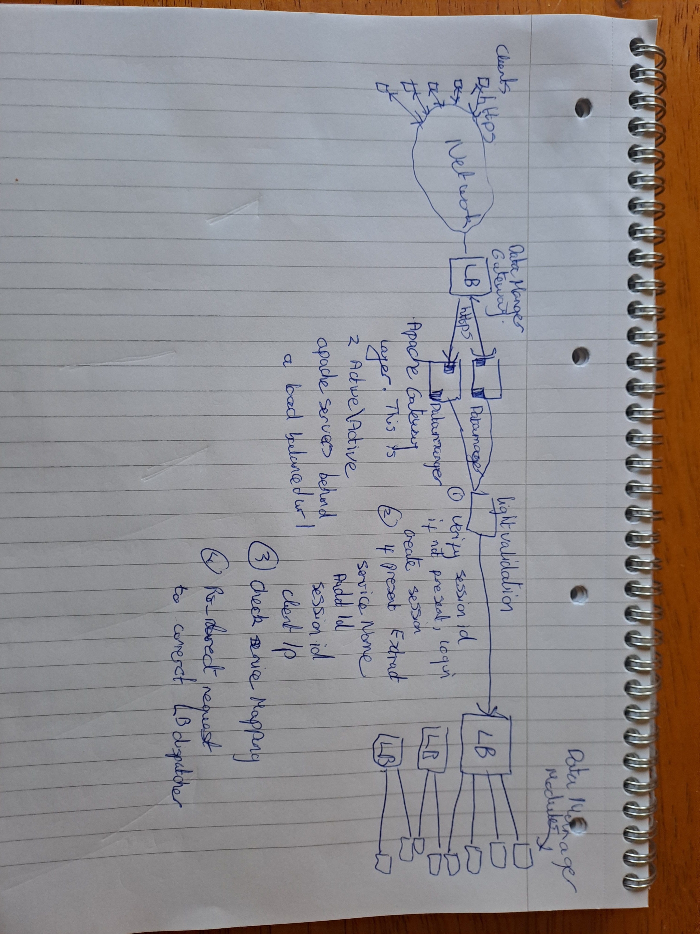
As a pre-req, we need to reactor all xml handling outside the CRUD modules. Lets deal with it at Request and response level. Can you please revied this document and let me have your thoughts. One thing I might add it where we need xml or json parsers, we should implement an open source one directly rather than use any hard coding etc.

Below is the proposal of a requet.

Request

<request version=”1.0”>
<External Audit Id>...</External Audit Id>
<session_id>...</session_id>

<transaction>

<operation>
...
</operation>

<operation>
...
</operation>

<operation>
...
</operation>

</transaction>

</request>

Level 1 parser

This parser takes the incoming request and performs the following tasks.

1: Determines the document type, e.g XML , JSON

2: Once document type is confirmed, verify the document is valid.

3: Once 2 is confirmed verify mandatory fields are present for exampe External Audit Id, Session Id , Operation or Create session if session Id is create session

4: Once 1,2,3 are confirmed the doc is valid return valid type of Input_c_request, else set error_detail to Request aborted. Level 1 parse failed.

We can take a copy XML_Runner and use the same technique to read all files in the input xml dirctory, load them into a dom or json library. Check they are valid. Can you give me the name of them xml and json libraries again we will use ? We should use the best most reliable open source. I would propose for the moment we just use the main logger for debugging.

Thanks Claude.

Level 2 parser

Lets assume that to start we will create a independent xml_handler. This could equally be JSON, but we will work with XML firsts and it should be easy enough to put in JSON handler next. The operations at this layer are as follows

1: Identify operation.

2: Validate operation is filled in correctly. You can use the existing validation in the OCI_Execute_query_Batch.c to start. Validation is to be done on all required fields.

3: If everything is okay then we need to parse the sql using the parser module.

4 : If every thing is good then we need to build a new C structure that will be passed to the crud layer, select, update, insert, delete etc.

The CRUD layer

This layer is now passed instead of INPUT_XML, it is passed INPUT_C_REQUEST. We need to define this. The CRUD layer accepts INPUT_C_REQUEST as validated and hence all xml validation can be removed from each module. The select, insert , update, delete and execute modules will need to be refactored to work of INPUT_C_REQUEST. The CRUD layer has 0 knowledge of what format the request was delivered in and processes using internal c structure rather than xml. The CRUD layer produces a response in a new object INPUT_C_RESPONSE. Everything else stays the same, e.g all methods, metrics, audit tails etc.

Output Response Layer

Once the Crud layer produces INPUT_C_RESPONSE this is then passed to a response layer. At this stage depending on the format of the input_request, be it xml or json a response is built containing the following

Response

<Response version =”1.0”>
<External Audit Id>...</External Audit Id>
<session_id>...</session_id>

/*This is a sample response from select module*/
<output_response> <execution_envelope> <sql_query>SELECT OCI_LOB_TEST.* FROM OCI_LOB_TEST order by 1</sql_query> </execution_envelope> <resultset> <row number="1"> <field><field_name>ID</field_name><field_type>NUMBER</field_type><field_value>1</field_value></field> <field><field_name>DESCRIPTION</field_name><field_type>STRING</field_type><field_value>Adam enjoying pizza</field_value></field> <field><field_name>FILE_NAME</field_name><field_type>STRING</field_type><field_value>Adam_1.jpg</field_value></field> <field><field_name>PHOTO</field_name><field_type>BLOB</field_type><field_value/><blob><file_name>Adam_1_20260712_142413_0.jpg</file_name><file_path>/home/leyden100/eclipse-workspace/OCI_Wrapper/output_lobs</file_path><file_url>https:</file_url><file_size>456547</file_size><mime_type>image/jpeg</mime_type></blob></field> </row> <row number="2"> <field><field_name>ID</field_name><field_type>NUMBER</field_type><field_value>2</field_value></field> <field><field_name>DESCRIPTION</field_name><field_type>STRING</field_type><field_value>Big hug for Emily</field_value></field> <field><field_name>FILE_NAME</field_name><field_type>STRING</field_type><field_value>Emily_big_hug.jpg</field_value></field> <field><field_name>PHOTO</field_name><field_type>BLOB</field_type><field_value/><blob><file_name>Emily_big_hug_20260712_142413_1.jpg</file_name><file_path>/home/leyden100/eclipse-workspace/OCI_Wrapper/output_lobs</file_path><file_url>https:</file_url><file_size>72585</file_size><mime_type>image/jpeg</mime_type></blob></field> </row> <row number="3"> <field><field_name>ID</field_name><field_type>NUMBER</field_type><field_value>3</field_value></field> <field><field_name>DESCRIPTION</field_name><field_type>STRING</field_type><field_value>Football Team</field_value></field> <field><field_name>FILE_NAME</field_name><field_type>STRING</field_type><field_value>Emily_Football.jpg</field_value></field> <field><field_name>PHOTO</field_name><field_type>BLOB</field_type><field_value/><blob><file_name>Emily_Football_20260712_142413_2.jpg</file_name><file_path>/home/leyden100/eclipse-workspace/OCI_Wrapper/output_lobs</file_path><file_url>https:</file_url><file_size>423891</file_size><mime_type>image/jpeg</mime_type></blob></field> </row> <row number="4"> <field><field_name>ID</field_name><field_type>NUMBER</field_type><field_value>4</field_value></field> <field><field_name>DESCRIPTION</field_name><field_type>STRING</field_type><field_value>Cousin Sophie</field_value></field> <field><field_name>FILE_NAME</field_name><field_type>STRING</field_type><field_value>Sophi.jpg</field_value></field> <field><field_name>PHOTO</field_name><field_type>BLOB</field_type><field_value/><blob><file_name>Sophi_20260712_142413_3.jpg</file_name><file_path>/home/leyden100/eclipse-workspace/OCI_Wrapper/output_lobs</file_path><file_url>https:</file_url><file_size>502790</file_size><mime_type>image/jpeg</mime_type></blob></field> </row> <row number="5"> <field><field_name>ID</field_name><field_type>NUMBER</field_type><field_value>5</field_value></field> <field><field_name>DESCRIPTION</field_name><field_type>STRING</field_type><field_value>The kids</field_value></field> <field><field_name>FILE_NAME</field_name><field_type>STRING</field_type><field_value>The_Gang.jpg</field_value></field> <field><field_name>PHOTO</field_name><field_type>BLOB</field_type><field_value/><blob><file_name>The_Gang_20260712_142413_4.jpg</file_name><file_path>/home/leyden100/eclipse-workspace/OCI_Wrapper/output_lobs</file_path><file_url>https:</file_url><file_size>670535</file_size><mime_type>image/jpeg</mime_type></blob></field> </row> <row number="6"> <field><field_name>ID</field_name><field_type>NUMBER</field_type><field_value>6</field_value></field> <field><field_name>DESCRIPTION</field_name><field_type>STRING</field_type><field_value>The one and only James</field_value></field> <field><field_name>FILE_NAME</field_name><field_type>STRING</field_type><field_value>Uncle_James.jpg</field_value></field> <field><field_name>PHOTO</field_name><field_type>BLOB</field_type><field_value/><blob><file_name>Uncle_James_20260712_142413_5.jpg</file_name><file_path>/home/leyden100/eclipse-workspace/OCI_Wrapper/output_lobs</file_path><file_url>https:</file_url><file_size>26263</file_size><mime_type>image/jpeg</mime_type></blob></field> </row> </resultset> <execution_envelope> <num_rows>6</num_rows> <execution_time_total>0.042934</execution_time_total> <fetch_batch_size>5</fetch_batch_size> <blobs_extracted>6</blobs_extracted> <clobs_extracted>0</clobs_extracted> </execution_envelope>

</output_response>

<status>
</status>
<error>
<code></code>
<message></message>
</error>
</request>

The response is then returned to the client in the original format.

We can start this refactor with the core OCI_execute_query_batch.c. We can do it in the following stages.

Stage 1 refactor xml.

1: Take all our test xml files and generate new request files using xml

2: Generate 1 request file combing all opetations in 1 file using xml.

4: Level 1 parser. This can be dropped in an independent request_handler module.

5: Like the xml runner lets have a new module called request_parser_layer_1. Loops through all requests in a given directory, these settings will come from config.ini, performs level1 parse.

6: If all passes, build Input_C_Request, if this level fails the request is aborted with relevant response to client is original formal.

7 : Create new module request_parser_layer 2. This module takes as input INPUT_C_Request and does the normal validation on new structure. if this level fails the request is aborted with relevant response to client is original formal.

8: continue module as normal using input_c_request / respomse

9 : convert response to original type

